ICS | 67.080.01
CCS | CSTC  B 31
中国热带作物学会团体标准
T/CSTC 00XX—XXXX

热带果蔬中农药残留快速筛查
液相色谱-串联质谱法

Rapid screening of pesticide residues in tropical fruits and vegetables
‒LC-MS/MS method

XXXX - XX - XX发布
XXXX - XX - XX实施
中国热带作物学会 发布

前言
本文件按照GB/T 1.1—2020《标准化工作导则 第1部分：标准化文件的结构和起草规则》的规定起草。
请注意本文件的某些内容可能涉及专利。本文件的发布机构不承担识别专利的责任。
本文件由中国热带作物学会提出并归口。
本文件起草单位：中国热带农业科学院分析测试中心、海南省现代农业检验检测预警防控中心、三亚市现代农业检验检测预警防控中心。
本文件主要起草人：张振山、黎舒怀、刘春华、吴学进、龚敏、何婷、李春丽、李萍萍、吴南村、黄燕霞、钟丽琪、尹桂豪、蒙雪茹、邢孔攀、李晓慧、黎小菊。

热带果蔬中农药残留快速筛查液相色谱-串联质谱法
  - 范围
本文件规定了水果和蔬菜中100种农药残留的快速定量筛查方法。
本文件适用于芒果、荔枝、香蕉、菠萝、豇豆、辣椒、丝瓜、苦瓜等热带果蔬中克百威、毒死蜱、氧乐果、氟虫腈等多种农药残留的定性鉴别和定量筛查，其它水果蔬菜可参照执行。
  - 规范性引用文件
下列文件中的内容通过文中的规范性引用而构成本文件必不可少的条款。其中，注日期的引用文件，仅该日期对应的版本适用于本文件；不注日期的引用文件，其最新版本（包括所有的修改单）适用于本文件。
GB 2763 食品安全国家标准 食品中农药最大残留限量
GB/T 6682 分析实验室用水规格和试验方法
GB/T 8855 新鲜水果和蔬菜的取样方法
  - 术语和定义
本文件没有需要界定的术语和定义。
  - 原理
试样用乙腈提取，提取液经固相萃取柱净化，液相色谱-质谱联用仪检测，外标法定量。
  - 试剂和材料
除非另有说明，所用试剂均为分析纯，水为GB/T 6682规定的一级水。
    - 试剂
      - 乙腈（CH₃CN，CAS号：75-05-8）。
      - 甲醇（CH₃OH，CAS号：67-56-1）。
      - 乙酸铵（CH₃COONH₄，CAS号：631-61-8）
    - 标准品
100种农药及其代谢物标准品，参见附录A.1，纯度≥95%。
    - 标准溶液配制
      - 标准储备溶液（100 mg/L）：吸取浓度为1000 mg/L各农药标准品1.00 mL，用乙腈溶解并定容至10 mL，避光-18℃及以下条件下保存，有效期1年。
      - 混合标准溶液：吸取一定量的农药标准储备溶液于10 mL容量瓶中，用乙腈定容至刻度。混合标准溶液避光0～4℃保存，有效期1个月。
    - 材料
      - 提取管：50 mL/2g。
      - 挤压式一步固相萃取柱：3 mL/180mg。
      - 微孔滤膜（有机相）：13 mm×0.22 μm。
  - 仪器
    - 液相色谱-三重四极杆质谱联用仪：配有电喷雾离子源（ESI）。
    - 分析天平：感量0.1 mg和0.01 g。
    - 离心机：转速不低于4200 r/min。
    - 组织捣碎机。
    - 涡旋混合器。
  - 试样制备与储存
样品取样部位按照GB 2763的规定执行。对于个体较小的样品，取样后全部处理；对于个体较大的基本均匀样品，可在对称轴或对称面上分割或切成小块后处理；对于细长、扁平或组分含量在各部分有差异的样品，可在不同部位切取小片或截成小段后处理；取后的样品将其切碎，充分混匀，用四分法取样或直接放入组织捣碎机中捣碎成匀浆，放入聚乙烯瓶中，制备好的样品不少于100 g。将试样置于于-18℃及以下条件下保存
  - 分析步骤
    - 提取
称取5 g试样（精确至0.01 g）于提取管中，加入5 mL乙腈，剧烈震荡2 min后4000 r/min离心5 min，吸取1 mL上清液于挤压式一步固相萃取柱中，以每秒1滴的流速缓慢过滤于进样瓶中，用于测定。
    - 测定
      - 液相色谱参考条件
- 色谱柱：C₁₈柱，2.1 mm（内径）×50 mm，粒径1.7 μm，或相当者。
- 流动相：A相为水（含5 mmol/L乙酸铵），B相为甲醇，流动相梯度条件见表1。
- 流速：0.3 mL/min。
- 柱温：35℃。
- 进样量：5 µL。
表1 流动相及其梯度条件（V_{A}+V_{B}）
时间min | 流动相V_{A} | 流动相V_{B}
0.00 | 90.0 | 10.0
1.00 | 90.0 | 10.0
2.00 | 30.0 | 70.0
4.00 | 30.0 | 70.0
5.00 | 5.00 | 95.0
8.00 | 5.00 | 95.0
9.00 | 90.0 | 10.0
10.0 | 90.0 | 10.0

      - 质谱参考条件
- 离子源类型：电喷雾离子源。
- 扫描方式：正源和负源同时扫描。
- 电喷雾电压：正源5500 V，负源-4500 V。
- 离子源温度：550℃。
- 雾化气：344.7 kPa。
- 辅助加热气：55.2 kPa。
- 气帘气：172.4 kPa。
- 多反应监测：每种农药分别选择一对定量离子，一对定性离子。每组所有需要检测离子对按照出峰顺序，分时段分别检测。每种农药的保留时间、定量离子对、定性离子对和离子对质谱参数，参见附录A.2。
      - 基质标准工作曲线
精确吸取一定量的混合标准溶液，逐级用空白基质溶液释成质量浓度为0.005 mg/L、0.01 mg/L、0.02 mg/L、0.05 mg/L、0.08 mg/L和0.10 mg/L的标准工作溶液，供液相色谱-质谱联用仪测定。以农药定量离子峰面积为纵坐标，农药标准溶液质量浓度为横坐标，绘制标准曲线。
      - 定性及定量
        - 保留时间
被测试样中目标农药色谱峰的保留时间与相应标准色谱峰的保留时间相比较，相对误差应在±2.5%之内。
        - 定量离子、定性离子及子离子丰度比
在相同实验条件下进行样品测定时，如果检出的色谱峰的保留时间与标准样品相一致，并且在扣除背景后的样品质谱图中，目标化合物的质谱定量和定性离子均出现，而且同一检测批次，对同一化合物，样品中目标化合物的定性离子和定量离子的相对丰度比与质量浓度相当的基质标准溶液相比，其允许偏差不超过表1规定的范围，则可判断样品中存在目标农药。
表2 定性时相对离子丰度的最大允许偏差
相对离子丰度 | ＞50% | ＞20%至50% | ＞10%至20% | ≤10%
允许相对偏差 | ±20% | ±25% | ±30% | ±50%
本方法的标准物质多反应监测UPLC-MS/MS色谱图参见附录B。
        - 定量
外标法定量。
    - 试样溶液的测定
将基质混合标准工作溶液和试样溶液依次注入液相色谱-质谱联用仪中，保留时间和定性离子定性，测得定量离子峰面积，待测样液中农药的响应值应在仪器检测的定量测定线性范围之内，超过线性范围时应根据测定浓度进行适当倍数稀释后再进行分析。
    - 平行试验
按8.1~8.3步骤对同一试样进行平行试验测定。
    - 空白试验
除不加试样外，采用完全相同的测定步骤进行平行操作。
  - 结果计算
试样中各农药残留量以质量分数ω计，数值以毫克每千克（mg/kg）表示，按公式（1）计算。
$ω=\frac{ρ×A×V}{A_{S}×m}×\frac{1000}{1000}$ ()
式中：
ω———试样中被测物残留量，单位为毫克每千克（mg/kg）；
ρ———基质标准工作溶液中被测物的质量浓度，单位为毫克每升（mg/L）；
A——试样溶液中被测物的色谱峰面积；
A_{s}——基质标准工作溶液中被测物的色谱峰面积；
V——提取液体积，单位为毫升（mL）；
m——试样的质量，单位为克（g）。
计算结果应扣除空白值，计算结果以重复性条件下获得的两次独立测定结果的算术平均值表示，保留两位有效数字，含量超1mg/kg时保留三位有效数字。
  - 精密度
在重复性条件下，获得的两次独立测试结果的绝对差值不得超过重复性限（r），参见附录D。
在再现性条件下，获得的两次独立测试结果的绝对差值不得超过再现性限（R），参见附录D。
  - 其他
本文件方法的定量限为0.01 mg/kg（见附录A）。

- （资料性）
100种农药及其代谢物中英文名称和定量限
100种农药及其代谢物的中文与英文名称和定量限见表A.1。
  - 100种农药及其代谢物中英文名称和方法定量限
序号 | 农药中文名 | 农药英文名 | 定量限 mg/kg
1 | 3-羟基克百威 | 3-hydroxy carbofuran | 0.01
2 | 阿维菌素 | abamectin | 0.01
3 | 乙酰甲胺磷 | acephate | 0.01
4 | 啶虫脒 | acetamiprid | 0.01
5 | 涕灭威 | aldicarb | 0.01
6 | 涕灭威砜 | aldicarb sulfone | 0.01
7 | 涕灭威亚砜 | aldicarb sulfoxide | 0.01
8 | 莠灭净 | ametryn | 0.01
9 | 嘧菌酯 | azoxystrobin | 0.01
10 | 啶酰菌胺 | boscalid | 0.01
11 | 噻嗪酮 | buprofezin | 0.01
12 | 甲萘威 | carbaryl | 0.01
13 | 多菌灵 | carbendazim | 0.01
14 | 克百威 | carbofuran | 0.01
15 | 丁硫克百威 | carbosulfan | 0.01
16 | 氯虫苯甲酰胺 | chlorantraniliprole | 0.01
17 | 灭幼脲 | chlorbenzuron | 0.01
18 | 杀虫脒 | chlordimeform | 0.01
19 | 虫螨腈 | chlorfenapyr | 0.01
20 | 氟啶脲 | chlorfluazuron | 0.01
21 | 毒死蜱 | chlorpyrifos | 0.01
22 | 噻虫胺 | clothianidin | 0.01
23 | 蝇毒磷 | coumaphos | 0.01
24 | 灭蝇胺 | cyromazine | 0.01
25 | 内吸磷 | demeton | 0.01
26 | 二嗪磷 | diazinon | 0.01
27 | 敌敌畏 | dichlorvos | 0.01
28 | 苯醚甲环唑 | difenoconazole | 0.01
29 | 除虫脲 | diflubenzuron | 0.01
30 | 乐果 | dimethoate | 0.01
31 | 烯酰吗啉 | dimethomorph | 0.01
32 | 甲氨基阿维菌素苯甲酸盐 | emamectin benzoate | 0.01
33 | 灭线磷 | ethoprophos | 0.01
34 | 醚菊酯 | etofenprox | 0.01
35 | 氯苯嘧啶醇 | fenarimol | 0.01
36 | 腈苯唑 | fenbuconazole | 0.01
37 | 杀螟硫磷 | fenitrothion | 0.01
38 | 倍硫磷 | fenthion | 0.01
39 | 倍硫磷砜 | fenthion sulfone | 0.01
40 | 倍硫磷亚砜 | fenthion sulfoxide | 0.01
41 | 氟虫腈 | fipronil | 0.01
42 | 氟甲腈 | fipronil desulfinyl | 0.01
43 | 氟虫腈硫醚 | fipronil sulfide | 0.01
44 | 氟虫腈砜 | fipronil sulfone | 0.01
45 | 氯吡脲 | forchlorfenuron | 0.01
46 | 赤霉酸 | gibberellic acid | 0.01
47 | 噻螨酮 | hexythiazox | 0.01
48 | 抑霉唑 | imazalil | 0.01
49 | 吡虫啉 | imidacloprid | 0.01
50 | 茚虫威 | indoxacarb | 0.01
51 | 异菌脲 | iprodione | 0.01
52 | 氯唑磷 | isazofos | 0.01
53 | 水胺硫磷 | isocarbophos | 0.01
54 | 甲基异柳磷 | isofenphos-methyl | 0.01
55 | 异丙威 | isoprocarb | 0.01
56 | 醚菌酯 | kresoxim-methyl | 0.01
57 | 马拉硫磷 | malathion | 0.01
58 | 甲霜灵 | metalaxyl | 0.01
59 | 甲胺磷 | methamidophos | 0.01
60 | 灭多威 | methomyl | 0.01
61 | 速灭磷 | mevinphos | 0.01
62 | 久效磷 | monocrotophos | 0.01
63 | 腈菌唑 | myclobutanil | 0.01
64 | 氧乐果 | omethoate | 0.01
65 | 多效唑 | paclobutrazol | 0.01
66 | 对硫磷 | parathion | 0.01
67 | 二甲戊灵 | pendimethalin | 0.01
68 | 甲拌磷 | phorate | 0.01
69 | 甲拌磷砜 | phorate sulfone | 0.01
70 | 甲拌磷亚砜 | phorate sulfoxide | 0.01
71 | 伏杀硫磷 | phosalone | 0.01
72 | 硫环磷 | phosfolan | 0.01
73 | 亚胺硫磷 | phosmet | 0.01
74 | 辛硫磷 | phoxim | 0.01
75 | 抗蚜威 | pirimicarb | 0.01
76 | 咪鲜胺 | prochloraz | 0.01
77 | 丙溴磷 | profenofos | 0.01
78 | 霜霉威 | propamocarb | 0.01
79 | 丙环唑 | propiconazole | 0.01
80 | 吡唑醚菌酯 | pyraclostrobin | 0.01
81 | 哒螨灵 | pyridaben | 0.01
82 | 嘧霉胺 | pyrimethanil | 0.01
83 | 乙基多杀菌素J | spinetoram J | 0.01
84 | 乙基多杀菌素L | spinetoram L | 0.01
85 | 多杀霉素A | spinosyn A | 0.01
86 | 多杀霉素D | spinosyn D | 0.01
87 | 螺螨酯 | spirodiclofen | 0.01
88 | 戊唑醇 | tebuconazole | 0.01
89 | 虫酰肼 | tebufenozide | 0.01
90 | 特丁硫磷 | terbufos | 0.01
91 | 特丁硫磷砜 | terbufos sulfone | 0.01
92 | 特丁硫磷亚砜 | terbufos sulfoxide | 0.01
93 | 噻虫嗪 | thiamethoxam | 0.01
94 | 噻苯隆 | thidiazuron | 0.01
95 | 甲基硫菌灵 | thiophanate-methyl | 0.01
96 | 唑虫酰胺 | tolfenpyrad | 0.01
97 | 三唑酮 | triadimefon | 0.01
98 | 三唑磷 | triazophos | 0.01
99 | 敌百虫 | trichlorfon | 0.01
100 | 肟菌酯 | trifloxystrobin | 0.01

- （资料性）
100种农药及其代谢物的保留时间、定量离子对、定性离子对
100种农药及其代谢物的保留时间、定量离子对、定性离子对见表B.1。

  - 100种农药及其代谢物的保留时间、定量离子对、定性离子对
序号 | 农药中文名 | 农药英文名 | 电离方式 | 保留时间（min） | 锥孔电压（V） | 定量离子 | 碰撞能量（V） | 定性离子 | 碰撞能量（V）
1 | 3-羟基克百威 | 3-hydroxy carbofuran | ESI+ | 5.21 | 60 | 238.1-181.1 | 16 | 238.1-163.2 | 18
2 | 阿维菌素 | abamectin | ESI+ | 8.21 | 100 | 895.5-751.6 | 63 | 895.5-449.3 | 64
3 | 乙酰甲胺磷 | acephate | ESI+ | 4.13 | 44 | 184-143 | 12 | 184-125 | 25
4 | 啶虫脒 | acetamiprid | ESI+ | 5.22 | 64 | 223-126 | 26 | 223-99.1 | 50
5 | 涕灭威 | aldicarb | ESI+ | 6.34 | 70 | 213-89.1 | 20 | 213-116 | 16
6 | 涕灭威砜 | aldicarb sulfone | ESI+ | 4.50 | 58 | 223.1-86 | 20 | 223.1-148.1 | 11
7 | 涕灭威亚砜 | aldicarb sulfoxide | ESI+ | 4.36 | 48 | 207.1-132 | 10 | 207.1-89.1 | 19
8 | 莠灭净 | ametryn | ESI+ | 7.96 | 80 | 228-96.1 | 35 | 228-158.1 | 31
9 | 嘧菌酯 | azoxystrobin | ESI+ | 7.86 | 60 | 404.1-372.1 | 22 | 404.1-344 | 35
10 | 啶酰菌胺 | boscalid | ESI+ | 7.99 | 100 | 343-307 | 28 | 343-140 | 27
11 | 噻嗪酮 | buprofezin | ESI+ | 8.60 | 100 | 306.2-116.2 | 21 | 306.2-106.1 | 35
12 | 甲萘威 | carbaryl | ESI+ | 7.47 | 56 | 202-145.1 | 15 | 202-127.1 | 40
13 | 多菌灵 | carbendazim | ESI+ | 5.07 | 101 | 192-160.1 | 25 | 192-132.1 | 44
14 | 克百威 | carbofuran | ESI+ | 7.22 | 70 | 222.1-165.2 | 16 | 222.1-123 | 28
15 | 丁硫克百威 | carbosulfan | ESI+ | 8.49 | 61 | 381.1-159.9 | 21 | 381.1-118.1 | 29
16 | 氯虫苯甲酰胺 | chlorantraniliprole | ESI+ | 7.81 | 80 | 484-452.9 | 30 | 484-285.9 | 19
17 | 灭幼脲 | chlorbenzuron | ESI+ | 8.27 | 66 | 309-156 | 21 | 309-139 | 40
18 | 杀虫脒 | chlordimeform | ESI+ | 4.86 | 39 | 197.2-117.1 | 39 | 197.2-125.1 | 45
19 | 虫螨腈 | chlorfenapyr | ESI- | 8.43 | -102 | 348.8-80.8 | -72 | 348.8-131 | -55
20 | 氟啶脲 | chlorfluazuron | ESI+ | 8.80 | 95 | 540-383 | 31 | 540-158.1 | 24
21 | 毒死蜱 | chlorpyrifos | ESI+ | 8.77 | 41 | 350-198 | 25 | 350-96.9 | 41
22 | 噻虫胺 | clothianidin | ESI+ | 5.05 | 51 | 250-169.1 | 17 | 250-132 | 21
23 | 蝇毒磷 | coumaphos | ESI+ | 8.28 | 105 | 363-227.1 | 35 | 363-307 | 24
24 | 灭蝇胺 | cyromazine | ESI+ | 3.76 | 61 | 167.2-85 | 24 | 167.2-125.1 | 25
25 | 内吸磷 | demeton | ESI+ | 5.98 | 48 | 259-89 | 22 | 259-61 | 45
26 | 二嗪磷 | diazinon | ESI+ | 8.34 | 56 | 305.1-169.2 | 27 | 305.1-153 | 27
27 | 敌敌畏 | dichlorvos | ESI+ | 7.18 | 45 | 221-109 | 25 | 221-127.1 | 24
28 | 苯醚甲环唑 | difenoconazole | ESI+ | 8.39 | 120 | 406.1-251 | 37 | 406.1-337.1 | 23
29 | 除虫脲 | diflubenzuron | ESI+ | 8.22 | 68 | 310.9-158.2 | 24 | 310.9-141.1 | 49
30 | 乐果 | dimethoate | ESI+ | 5.36 | 24 | 230-125 | 22 | 230-199 | 10
31 | 烯酰吗啉 | dimethomorph | ESI+ | 8.00 | 130 | 388-301 | 31 | 388-165.1 | 41
32 | 甲氨基阿维菌素苯甲酸盐 | emamectin benzoate | ESI+ | 8.24 | 134 | 886.6-158.2 | 40 | 886.6-302.1 | 41
33 | 灭线磷 | ethoprophos | ESI+ | 8.20 | 67 | 243-97 | 43 | 243-131 | 26
34 | 醚菊酯 | etofenprox | ESI+ | 8.71 | 41 | 394.1-107.1 | 53 | 394.1-177.2 | 19
35 | 氯苯嘧啶醇 | fenarimol | ESI+ | 8.16 | 43 | 331-268.1 | 30 | 331-259.1 | 31
36 | 腈苯唑 | fenbuconazole | ESI+ | 8.17 | 95 | 337.1-124.9 | 42 | 337.1-70 | 43
37 | 杀螟硫磷 | fenitrothion | ESI+ | 7.62 | 30 | 278-125 | 25 | 278-246 | 21
38 | 倍硫磷 | fenthion | ESI+ | 8.31 | 30 | 279-247 | 18 | 279-169 | 16
39 | 倍硫磷砜 | fenthion sulfone | ESI+ | 7.43 | 32 | 311-125 | 22 | 311-109 | 28
40 | 倍硫磷亚砜 | fenthion sulfoxide | ESI+ | 7.27 | 32 | 295-280 | 18 | 295-109 | 32
41 | 氟虫腈 | fipronil | ESI- | 8.15 | -66 | 434.8-329.8 | -21 | 434.8-249.9 | -36
42 | 氟甲腈 | fipronil desulfinyl | ESI- | 8.10 | -75 | 387-351 | -19 | 387-281.9 | -46
43 | 氟虫腈硫醚 | fipronil sulfide | ESI- | 8.17 | -78 | 418.8-382.9 | -21 | 418.8-261.8 | -39
44 | 氟虫腈砜 | fipronil sulfone | ESI- | 8.20 | -88 | 450.9-414.9 | -23 | 450.9-281.9 | -39
45 | 氯吡脲 | forchlorfenuron | ESI+ | 7.79 | 80 | 248.1-129 | 25 | 248.1-155 | 25
46 | 赤霉酸 | gibberellic acid | ESI+ | 5.08 | -45 | 345.1-239.2 | -21 | 345.1-143.2 | -34
47 | 噻螨酮 | hexythiazox | ESI+ | 8.75 | 76 | 353-228 | 21 | 353-168 | 33
48 | 抑霉唑 | imazalil | ESI+ | 7.66 | 61 | 297.1-159.2 | 35 | 297.1-255 | 25
49 | 吡虫啉 | imidacloprid | ESI+ | 4.98 | 58 | 256.1-209.1 | 24 | 256.1-175.1 | 27
50 | 茚虫威 | indoxacarb | ESI+ | 8.31 | 96 | 528-203 | 51 | 528-56 | 55
51 | 异菌脲 | iprodione | ESI+ | 8.20 | 30 | 330-245 | 20 | 330-288 | 18
52 | 氯唑磷 | isazofos | ESI+ | 8.12 | 70 | 316-164 | 23 | 316-122 | 35
53 | 水胺硫磷 | isocarbophos | ESI+ | 7.75 | 100 | 231-121 | 26 | 231-109 | 38
54 | 甲基异柳磷 | isofenphos-methyl | ESI+ | 8.24 | 20 | 332-121 | 43 | 332-231 | 19
55 | 异丙威 | isoprocarb | ESI+ | 7.73 | 57 | 194-95 | 19 | 194-137 | 12
56 | 醚菌酯 | kresoxim-methyl | ESI+ | 8.26 | 60 | 314.1-267 | 15 | 314.1-222 | 20
57 | 马拉硫磷 | malathion | ESI+ | 7.54 | 46 | 331-99.1 | 31 | 331-127.1 | 17
58 | 甲霜灵 | metalaxyl | ESI+ | 7.75 | 57 | 280.2-220.2 | 18 | 280.2-192.3 | 23
59 | 甲胺磷 | methamidophos | ESI+ | 3.08 | 50 | 142-94 | 20 | 142-125 | 18
60 | 灭多威 | methomyl | ESI+ | 4.65 | 36 | 163-88 | 13 | 163-106 | 13
61 | 速灭磷 | mevinphos | ESI+ | 5.70 | 55 | 225-127 | 21 | 225-193 | 9
62 | 久效磷 | monocrotophos | ESI+ | 4.75 | 60 | 224.1-98 | 17 | 224.1-127 | 21
63 | 腈菌唑 | myclobutanil | ESI+ | 8.07 | 80 | 289-70 | 35 | 289-125 | 46
64 | 氧乐果 | omethoate | ESI+ | 4.29 | 45 | 214-125 | 30 | 214-183 | 15
65 | 多效唑 | paclobutrazol | ESI+ | 8.05 | 100 | 294.1-70.1 | 45 | 294.1-125 | 45
66 | 对硫磷 | parathion | ESI+ | 8.24 | 73 | 292-236 | 20 | 292-264 | 15
67 | 二甲戊灵 | pendimethalin | ESI+ | 7.75 | 45 | 282.1-212 | 15 | 282.1-194 | 25
68 | 甲拌磷 | phorate | ESI+ | 5.20 | 51 | 261.1-75.2 | 21 | 261.1-47 | 53
69 | 甲拌磷砜 | phorate sulfone | ESI+ | 7.67 | 65 | 293-96.9 | 50 | 293-114.7 | 35
70 | 甲拌磷亚砜 | phorate sulfoxide | ESI+ | 7.61 | 25 | 277-199 | 13 | 277-153 | 19
71 | 伏杀硫磷 | phosalone | ESI+ | 8.35 | 65 | 368-182 | 20 | 368-111 | 51
72 | 硫环磷 | phosfolan | ESI+ | 5.98 | 40 | 256.1-140 | 30 | 256.1-228 | 18
73 | 亚胺硫磷 | phosmet | ESI+ | 7.88 | 51 | 318-160 | 19 | 318-133 | 49
74 | 辛硫磷 | phoxim | ESI+ | 8.31 | 56 | 299-77.1 | 49 | 299-129.2 | 19
75 | 抗蚜威 | pirimicarb | ESI+ | 7.43 | 76 | 239.2-182 | 21 | 239.2-72 | 36
76 | 咪鲜胺 | prochloraz | ESI+ | 8.37 | 41 | 376.2-308 | 17 | 376.2-266 | 22
77 | 丙溴磷 | profenofos | ESI+ | 8.56 | 80 | 373-302.9 | 25 | 373-345.2 | 18
78 | 霜霉威 | propamocarb | ESI+ | 4.38 | 51 | 189.1-102.1 | 25 | 189.1-144.1 | 19
79 | 丙环唑 | propiconazole | ESI+ | 8.33 | 70 | 342.1-159 | 43 | 342.1-69.1 | 43
80 | 吡唑醚菌酯 | pyraclostrobin | ESI+ | 8.31 | 28 | 388.2-194.1 | 16 | 388.2-163.1 | 30
81 | 哒螨灵 | pyridaben | ESI+ | 9.22 | 46 | 365-147 | 31 | 365-309 | 19
82 | 嘧霉胺 | pyrimethanil | ESI+ | 8.05 | 100 | 200.1-107.1 | 33 | 200.1-82 | 33
83 | 乙基多杀菌素J | spinetoram J | ESI+ | 8.17 | 40 | 748.5-142.1 | 37 | 748.5-203.1 | 42
84 | 乙基多杀菌素L | spinetoram L | ESI+ | 8.25 | 80 | 760.4-142 | 35 | 760.4-98 | 100
85 | 多杀霉素A | spinosyn A | ESI+ | 8.10 | 110 | 732.4-142 | 35 | 732.4-98.1 | 95
86 | 多杀霉素D | spinosyn D | ESI+ | 8.18 | 110 | 746.4-142 | 34 | 746.4-98.1 | 101
87 | 螺螨酯 | spirodiclofen | ESI+ | 8.93 | 40 | 411.3-313.2 | 25 | 411.3-213.1 | 35
88 | 戊唑醇 | tebuconazole | ESI+ | 8.32 | 95 | 308-70 | 49 | 308-125 | 47
89 | 虫酰肼 | tebufenozide | ESI+ | 8.21 | 61 | 353.3-133.1 | 23 | 353.2-297.1 | 15
90 | 特丁硫磷 | terbufos | ESI+ | 8.66 | 45 | 289.1-103.1 | 14 | 289.1-187 | 19
91 | 特丁硫磷砜 | terbufos sulfone | ESI+ | 7.91 | 68 | 321.1-171.1 | 17 | 321.1-143.1 | 28
92 | 特丁硫磷亚砜 | terbufos sulfoxide | ESI+ | 7.91 | 90 | 305-187.1 | 15 | 305-97 | 59
93 | 噻虫嗪 | thiamethoxam | ESI+ | 4.73 | 53 | 292.1-211 | 17 | 292.1-181 | 30
94 | 噻苯隆 | thidiazuron | ESI+ | 7.25 | 30 | 221-102 | 22 | 221-128 | 22
95 | 甲基硫菌灵 | thiophanate-methyl | ESI+ | 7.00 | 60 | 343-151 | 26 | 343-311 | 15
96 | 唑虫酰胺 | tolfenpyrad | ESI+ | 8.58 | 40 | 384.1-197.1 | 35 | 384.1-171 | 33
97 | 三唑酮 | triadimefon | ESI+ | 8.09 | 70 | 294-197 | 21 | 294-225 | 17
98 | 三唑磷 | triazophos | ESI+ | 8.10 | 85 | 314-162.1 | 28 | 314-119.1 | 49
99 | 敌百虫 | trichlorfon | ESI+ | 5.40 | 45 | 256.9-109 | 25 | 256.9-127.1 | 24
100 | 肟菌酯 | trifloxystrobin | ESI+ | 8.36 | 40 | 409.1-186 | 23 | 409.1-145 | 63

- (资料性）
100种农药及其代谢物多反应监测（MRM）色谱图
100种农药及其代谢物多反应监测（MRM）色谱图见图C.1。
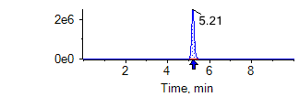  1. 3-羟基克百威  3-hydroxy carbofuran | 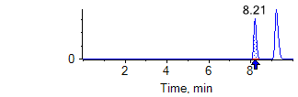  2. 阿维菌素  abamectin | 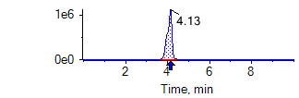  3. 乙酰甲胺磷  acephate | 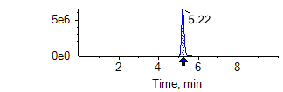  4. 啶虫脒  acetamiprid
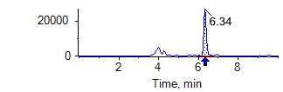  5. 涕灭威  aldicarb | 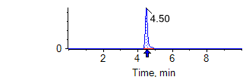  6. 涕灭威砜  ldicarb sulfone | 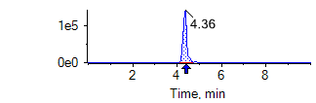  7. 涕灭威亚砜  aldicarb sulfoxide | 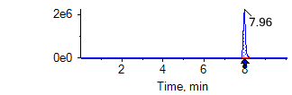  8. 莠灭净  ametryn
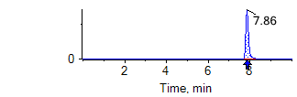  9. 嘧菌酯  azoxystrobin | 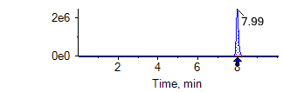  10. 啶酰菌胺  boscalid | 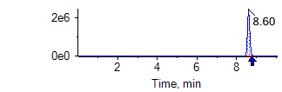  11. 噻嗪酮  buprofezin | 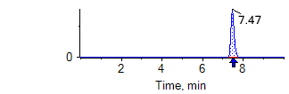  12. 甲萘威  carbaryl
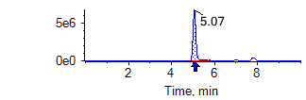  13. 多菌灵  carbendazim | 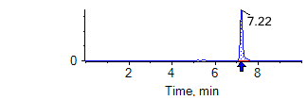  14. 克百威  carbofuran | 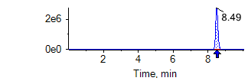  15. 丁硫克百威  carbosulfan | 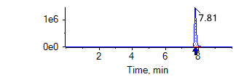  16. 氯虫苯甲酰胺  chlorantraniliprole
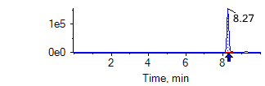  17. 灭幼脲  chlorbenzuron | 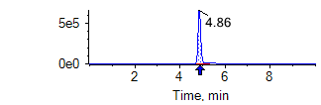  18. 杀虫脒  chlordimeform | 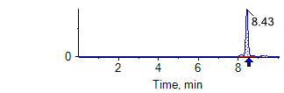  19. 虫螨腈  chlorfenapyr | 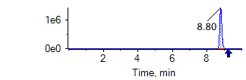  20. 氟啶脲  chlorfluazuron
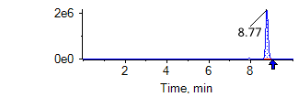  21. 毒死蜱  chlorpyrifos | 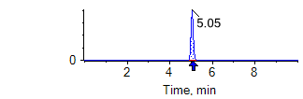  22. 噻虫胺  clothianidin | 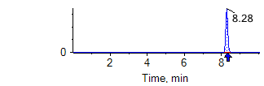  23. 蝇毒磷  coumaphos | 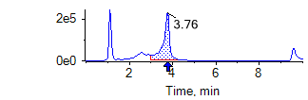  24. 灭蝇胺  cyromazine
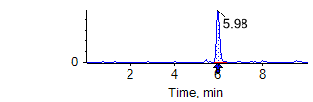  25. 内吸磷  demeton | 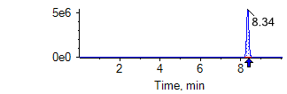  26. 二嗪磷  diazinon | 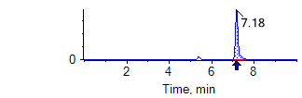  27. 敌敌畏  dichlorvos | 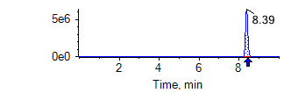  28. 苯醚甲环唑  difenoconazole
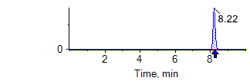  29. 除虫脲  diflubenzuron | 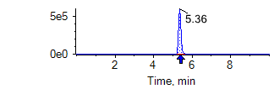  30. 乐果  dimethoate | 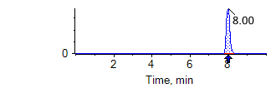  31. 烯酰吗啉  dimethomorph | 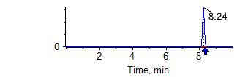  32. 甲氨基阿维菌素苯甲酸盐  emamectin benzoate
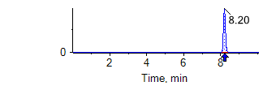  33. 灭线磷  ethoprophos | 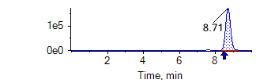  34. 醚菊酯  etofenprox | 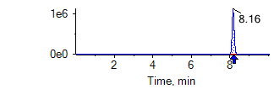  35. 氯苯嘧啶醇  fenarimol | 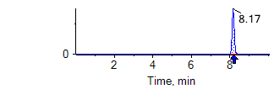  36. 腈苯唑  fenbuconazole
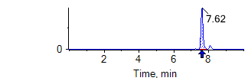  37. 杀螟硫磷  fenitrothion | 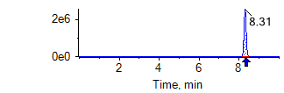  38. 倍硫磷  fenthion | 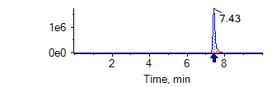  39. 倍硫磷砜  fenthion sulfone | 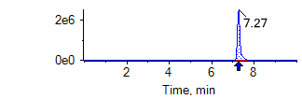  40. 倍硫磷亚砜  fenthion sulfoxide
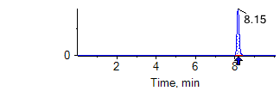  41. 氟虫腈  fipronil | 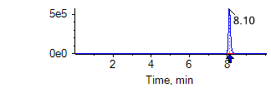  42. 氟甲腈  fipronil desulfinyl | 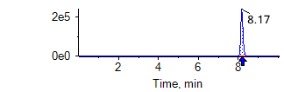  43. 氟虫腈硫醚  fipronil sulfide | 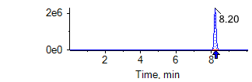  44. 氟虫腈砜  fipronil sulfone
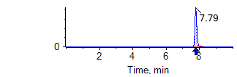  45. 氯吡脲  forchlorfenuron | 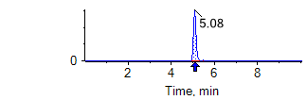  46. 赤霉酸  gibberellic acid | 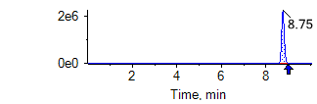  47. 噻螨酮  hexythiazox | 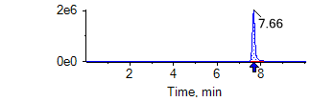  48. 抑霉唑  imazalil
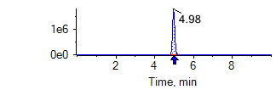  49. 吡虫啉  imidacloprid | 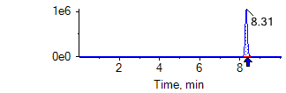  50. 茚虫威  indoxacarb | 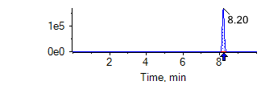  51. 异菌脲  iprodione | 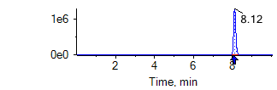  52. 氯唑磷  isazofos
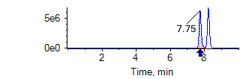  53. 水胺硫磷  isocarbophos | 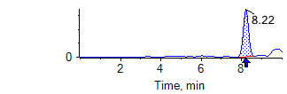  54. 甲基异柳磷  isofenphos-methyl | 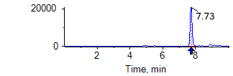  55. 异丙威  isoprocarb | 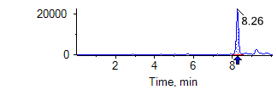  56. 醚菌酯  kresoxim-methyl
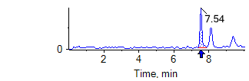  57. 马拉硫磷  malathion | 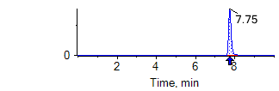  58. 甲霜灵  metalaxyl | 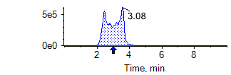  59. 甲胺磷  methamidophos | 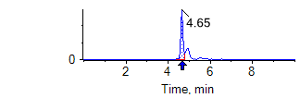  60. 灭多威  methomyl
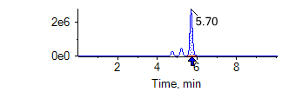  61. 速灭磷  mevinphos | 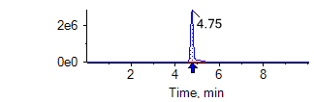  62. 久效磷  monocrotophos | 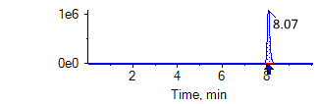  63. 腈菌唑  myclobutanil | 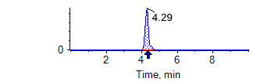  64. 氧乐果  omethoate
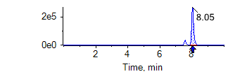  65. 多效唑  paclobutrazol | 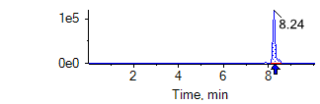  66. 对硫磷  parathion | 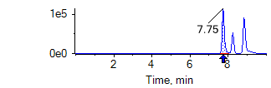  67. 二甲戊灵  pendimethalin | 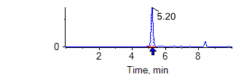  68. 甲拌磷  phorate
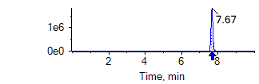  69. 甲拌磷砜  phorate sulfone | 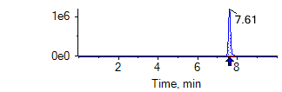  70. 甲拌磷亚砜  phorate sulfoxide | 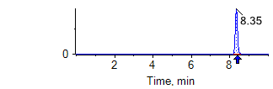  71. 伏杀硫磷  phosalone | 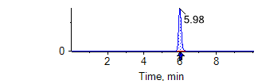  72. 硫环磷  phosfolan
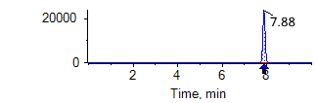  73. 亚胺硫磷  phosmet | 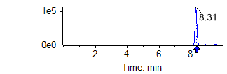  74. 辛硫磷  phoxim | 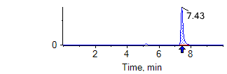  75. 抗蚜威  pirimicarb | 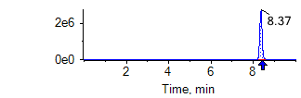  76. 咪鲜胺  prochloraz
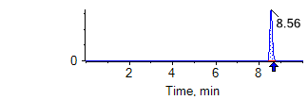  77. 丙溴磷  profenofos | 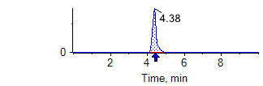  78. 霜霉威  propamocarb | 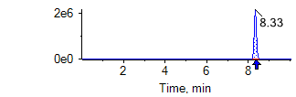  79. 丙环唑  propiconazole | 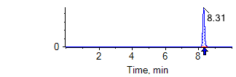  80. 吡唑醚菌酯  pyraclostrobin
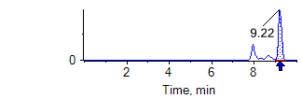  81. 哒螨灵  pyridaben | 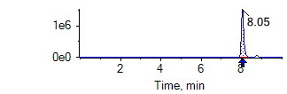  82. 嘧霉胺  pyrimethanil | 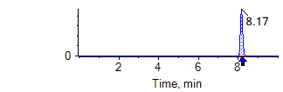  83. 乙基多杀菌素J  spinetoram J | 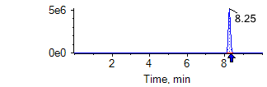  84. 乙基多杀菌素L  spinetoram L
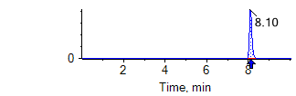  85. 多杀霉素A  spinosyn A | 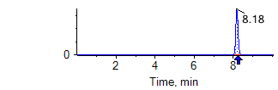  86. 多杀霉素D  spinosyn D | 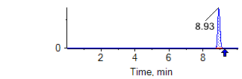  87. 螺螨酯  spirodiclofen | 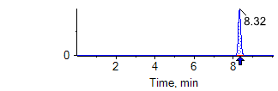  88. 戊唑醇  tebuconazole
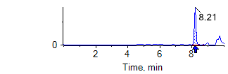  89.虫酰肼  tebufenozide | 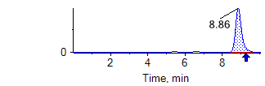  90. 特丁硫磷  terbufos | 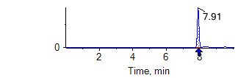  91. 特丁硫磷砜  terbufos sulfone | 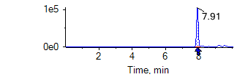  92. 特丁硫磷亚砜  terbufos sulfoxide
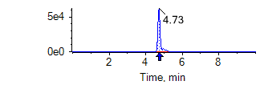  93. 噻虫嗪  thiamethoxam | 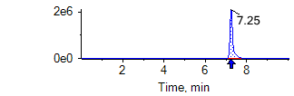  94. 噻苯隆  thidiazuron | 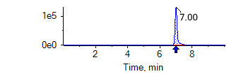  95. 甲基硫菌灵  thiophanate-methyl | 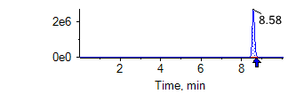  96. 唑虫酰胺  tolfenpyrad
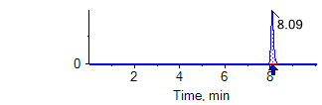  97. 三唑酮  triadimefon | 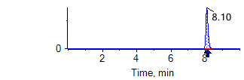  98. 三唑磷  triazophos | 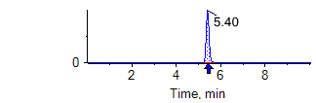  99. 敌百虫  trichlorfon | 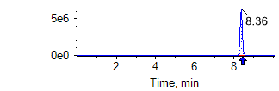  100. 肟菌酯  trifloxystrobin

  - 100种农药及其代谢物多反应监测（MRM）色谱图

- (资料性）
100种农药及其代谢物的精密度的表示和计算
重复性限（r）要求见表D.1，再现性限（R）要求见表D.2。

  - 重复性限（R）
序号 | 名称 | 农药英文名 | 重复性限r
 |  |  | 豇豆等蔬菜（mg/kg） |  |  | 芒果等水果（mg/kg）
 |  |  | 0.01 | 0.02 | 0.1 | 0.01 | 0.02 | 0.1
1 | 3-羟基克百威 | 3-hydroxy carbofuran | 0.00070 | 0.00231 | 0.00876 | 0.00110 | 0.00213 | 0.00980
2 | 阿维菌素 | abamectin | 0.00114 | 0.00232 | 0.00559 | 0.00101 | 0.00197 | 0.00625
3 | 乙酰甲胺磷 | acephate | 0.00099 | 0.00210 | 0.00579 | 0.00101 | 0.00196 | 0.00616
4 | 啶虫脒 | acetamiprid | 0.00088 | 0.00206 | 0.00842 | 0.00104 | 0.00207 | 0.00824
5 | 涕灭威 | aldicarb | 0.00097 | 0.00228 | 0.00566 | 0.00097 | 0.00206 | 0.00559
6 | 涕灭威砜 | aldicarb sulfone | 0.00084 | 0.00220 | 0.00932 | 0.00147 | 0.00234 | 0.01389
7 | 涕灭威亚砜 | aldicarb sulfoxide | 0.00105 | 0.00183 | 0.01108 | 0.00116 | 0.00202 | 0.01219
8 | 莠灭净 | ametryn | 0.00109 | 0.00272 | 0.00949 | 0.00102 | 0.00257 | 0.00979
9 | 嘧菌酯 | azoxystrobin | 0.00099 | 0.00209 | 0.00396 | 0.00096 | 0.00212 | 0.00425
10 | 啶酰菌胺 | boscalid | 0.00092 | 0.00253 | 0.01137 | 0.00125 | 0.00245 | 0.01198
11 | 噻嗪酮 | buprofezin | 0.00111 | 0.00211 | 0.01091 | 0.00126 | 0.00241 | 0.01006
12 | 甲萘威 | carbaryl | 0.00099 | 0.00217 | 0.01044 | 0.00127 | 0.00203 | 0.01294
13 | 多菌灵 | carbendazim | 0.00105 | 0.00205 | 0.00456 | 0.00108 | 0.00203 | 0.00445
14 | 克百威 | carbofuran | 0.00095 | 0.00182 | 0.01045 | 0.00089 | 0.00208 | 0.00883
15 | 丁硫克百威 | carbosulfan | 0.00109 | 0.00211 | 0.00651 | 0.00088 | 0.00221 | 0.00627
16 | 氯虫苯甲酰胺 | chlorantraniliprole | 0.00116 | 0.00224 | 0.01039 | 0.00133 | 0.00292 | 0.00960
17 | 灭幼脲 | chlorbenzuron | 0.00097 | 0.00172 | 0.00993 | 0.00127 | 0.00239 | 0.01536
18 | 杀虫脒 | chlordimeform | 0.00098 | 0.00239 | 0.00576 | 0.00105 | 0.00224 | 0.00652
19 | 虫螨腈 | chlorfenapyr | 0.00113 | 0.00202 | 0.00543 | 0.00108 | 0.00249 | 0.00631
20 | 氟啶脲 | chlorfluazuron | 0.00087 | 0.00217 | 0.01068 | 0.00129 | 0.00212 | 0.01280
21 | 毒死蜱 | chlorpyrifos | 0.00098 | 0.00204 | 0.00590 | 0.00101 | 0.00217 | 0.00722
22 | 噻虫胺 | clothianidin | 0.00108 | 0.00196 | 0.00440 | 0.00098 | 0.00216 | 0.00419
23 | 蝇毒磷 | coumaphos | 0.00104 | 0.00242 | 0.00620 | 0.00103 | 0.00214 | 0.00598
24 | 灭蝇胺 | cyromazine | 0.00110 | 0.00180 | 0.00657 | 0.00104 | 0.00216 | 0.00662
25 | 内吸磷 | demeton | 0.00104 | 0.00242 | 0.00622 | 0.00108 | 0.00228 | 0.00543
26 | 二嗪磷 | diazinon | 0.00110 | 0.00220 | 0.00539 | 0.00101 | 0.00246 | 0.00501
27 | 敌敌畏 | dichlorvos | 0.00108 | 0.00219 | 0.00878 | 0.00131 | 0.00256 | 0.01353
28 | 苯醚甲环唑 | difenoconazole | 0.00106 | 0.00205 | 0.00423 | 0.00103 | 0.00214 | 0.00416
29 | 除虫脲 | diflubenzuron | 0.00112 | 0.00213 | 0.00705 | 0.00105 | 0.00214 | 0.00659
30 | 乐果 | dimethoate | 0.00106 | 0.00172 | 0.00691 | 0.00104 | 0.00213 | 0.00680
31 | 烯酰吗啉 | dimethomorph | 0.00091 | 0.00207 | 0.00788 | 0.00104 | 0.00210 | 0.00798
32 | 甲氨基阿维菌素苯甲酸盐 | emamectin benzoate | 0.00096 | 0.00213 | 0.00570 | 0.00103 | 0.00197 | 0.00532
33 | 灭线磷 | ethoprophos | 0.00101 | 0.00205 | 0.00662 | 0.00095 | 0.00205 | 0.00569
34 | 醚菊酯 | etofenprox | 0.00086 | 0.00209 | 0.01102 | 0.00115 | 0.00267 | 0.01380
35 | 氯苯嘧啶醇 | fenarimol | 0.00112 | 0.00250 | 0.01171 | 0.00146 | 0.00273 | 0.01461
36 | 腈苯唑 | fenbuconazole | 0.00089 | 0.00235 | 0.01167 | 0.00166 | 0.00295 | 0.01077
37 | 杀螟硫磷 | fenitrothion | 0.00111 | 0.00235 | 0.00667 | 0.00107 | 0.00208 | 0.00542
38 | 倍硫磷 | fenthion | 0.00113 | 0.00219 | 0.00644 | 0.00117 | 0.00209 | 0.00665
39 | 倍硫磷砜 | fenthion sulfone | 0.00094 | 0.00198 | 0.01129 | 0.00107 | 0.00278 | 0.01053
40 | 倍硫磷亚砜 | fenthion sulfoxide | 0.00118 | 0.00192 | 0.00728 | 0.00122 | 0.00211 | 0.01054
41 | 氟虫腈 | fipronil | 0.00096 | 0.00195 | 0.01133 | 0.00127 | 0.00277 | 0.00956
42 | 氟甲腈 | fipronil desulfinyl | 0.00100 | 0.00185 | 0.00972 | 0.00148 | 0.00222 | 0.01211
43 | 氟虫腈硫醚 | fipronil sulfide | 0.00108 | 0.00187 | 0.00903 | 0.00114 | 0.00250 | 0.01061
44 | 氟虫腈砜 | fipronil sulfone | 0.00081 | 0.00232 | 0.01016 | 0.00128 | 0.00250 | 0.01328
45 | 氯吡脲 | forchlorfenuron | 0.00106 | 0.00204 | 0.01024 | 0.00127 | 0.00207 | 0.01146
46 | 赤霉酸 | gibberellic acid | 0.00110 | 0.00192 | 0.01138 | 0.00124 | 0.00213 | 0.01240
47 | 噻螨酮 | hexythiazox | 0.00087 | 0.00233 | 0.01215 | 0.00110 | 0.00258 | 0.01459
48 | 抑霉唑 | imazalil | 0.00105 | 0.00174 | 0.01165 | 0.00121 | 0.00246 | 0.01223
49 | 吡虫啉 | imidacloprid | 0.00091 | 0.00217 | 0.00975 | 0.00129 | 0.00214 | 0.01118
50 | 茚虫威 | indoxacarb | 0.00099 | 0.00210 | 0.00969 | 0.00126 | 0.00241 | 0.01337
51 | 异菌脲 | iprodione | 0.00096 | 0.00191 | 0.00754 | 0.00103 | 0.00201 | 0.00629
52 | 氯唑磷 | isazofos | 0.00117 | 0.00193 | 0.00609 | 0.00103 | 0.00226 | 0.00524
53 | 水胺硫磷 | isocarbophos | 0.00101 | 0.00209 | 0.00553 | 0.00101 | 0.00209 | 0.00667
54 | 甲基异柳磷 | isofenphos-methyl | 0.00109 | 0.00227 | 0.00541 | 0.00108 | 0.00216 | 0.00561
55 | 异丙威 | isoprocarb | 0.00108 | 0.00189 | 0.00938 | 0.00129 | 0.00283 | 0.01310
56 | 醚菌酯 | kresoxim-methyl | 0.00113 | 0.00189 | 0.00451 | 0.00101 | 0.00205 | 0.00466
57 | 马拉硫磷 | malathion | 0.00125 | 0.00238 | 0.00616 | 0.00110 | 0.00251 | 0.00543
58 | 甲霜灵 | metalaxyl | 0.00109 | 0.00195 | 0.00388 | 0.00105 | 0.00177 | 0.00477
59 | 甲胺磷 | methamidophos | 0.00102 | 0.00209 | 0.00629 | 0.00117 | 0.00207 | 0.00654
60 | 灭多威 | methomyl | 0.00103 | 0.00243 | 0.00976 | 0.00149 | 0.00241 | 0.01323
61 | 速灭磷 | mevinphos | 0.00095 | 0.00207 | 0.00616 | 0.00098 | 0.00203 | 0.00614
62 | 久效磷 | monocrotophos | 0.00110 | 0.00214 | 0.00683 | 0.00104 | 0.00226 | 0.00526
63 | 腈菌唑 | myclobutanil | 0.00111 | 0.00210 | 0.00958 | 0.00120 | 0.00221 | 0.00976
64 | 氧乐果 | omethoate | 0.00101 | 0.00214 | 0.00710 | 0.00095 | 0.00205 | 0.00585
65 | 多效唑 | paclobutrazol | 0.00108 | 0.00213 | 0.01366 | 0.00129 | 0.00224 | 0.01441
66 | 对硫磷 | parathion | 0.00114 | 0.00192 | 0.00603 | 0.00105 | 0.00206 | 0.00550
67 | 二甲戊灵 | pendimethalin | 0.00103 | 0.00203 | 0.00748 | 0.00094 | 0.00229 | 0.00845
68 | 甲拌磷 | phorate | 0.00116 | 0.00199 | 0.00578 | 0.00115 | 0.00215 | 0.00529
69 | 甲拌磷砜 | phorate sulfone | 0.00094 | 0.00211 | 0.00590 | 0.00116 | 0.00245 | 0.00554
70 | 甲拌磷亚砜 | phorate sulfoxide | 0.00088 | 0.00220 | 0.00581 | 0.00105 | 0.00250 | 0.00546
71 | 伏杀硫磷 | phosalone | 0.00125 | 0.00213 | 0.00866 | 0.00096 | 0.00249 | 0.01359
72 | 硫环磷 | phosfolan | 0.00108 | 0.00198 | 0.00650 | 0.00100 | 0.00203 | 0.00630
73 | 亚胺硫磷 | phosmet | 0.00124 | 0.00215 | 0.00564 | 0.00093 | 0.00222 | 0.00566
74 | 辛硫磷 | phoxim | 0.00096 | 0.00190 | 0.01066 | 0.00131 | 0.00228 | 0.01073
75 | 抗蚜威 | pirimicarb | 0.00103 | 0.00240 | 0.01153 | 0.00138 | 0.00256 | 0.01151
76 | 咪鲜胺 | prochloraz | 0.00104 | 0.00211 | 0.00780 | 0.00103 | 0.00219 | 0.00774
77 | 丙溴磷 | profenofos | 0.00097 | 0.00226 | 0.01104 | 0.00135 | 0.00224 | 0.01078
78 | 霜霉威 | propamocarb | 0.00098 | 0.00246 | 0.00613 | 0.00095 | 0.00229 | 0.00653
79 | 丙环唑 | propiconazole | 0.00105 | 0.00265 | 0.00929 | 0.00115 | 0.00231 | 0.01296
80 | 吡唑醚菌酯 | pyraclostrobin | 0.00103 | 0.00212 | 0.00365 | 0.00091 | 0.00222 | 0.00387
81 | 哒螨灵 | pyridaben | 0.00103 | 0.00220 | 0.01167 | 0.00116 | 0.00217 | 0.01388
82 | 嘧霉胺 | pyrimethanil | 0.00091 | 0.00201 | 0.00378 | 0.00088 | 0.00185 | 0.00440
83 | 乙基多杀菌素J | spinetoram J | 0.00094 | 0.00184 | 0.00836 | 0.00100 | 0.00172 | 0.00918
84 | 乙基多杀菌素L | spinetoram L | 0.00109 | 0.00192 | 0.00753 | 0.00094 | 0.00226 | 0.00733
85 | 多杀霉素A | spinosyn A | 0.00087 | 0.00227 | 0.01132 | 0.00122 | 0.00206 | 0.01162
86 | 多杀霉素D | spinosyn D | 0.00101 | 0.00162 | 0.00943 | 0.00115 | 0.00292 | 0.00941
87 | 螺螨酯 | spirodiclofen | 0.00108 | 0.00205 | 0.01063 | 0.00106 | 0.00255 | 0.01283
88 | 戊唑醇 | tebuconazole | 0.00111 | 0.00213 | 0.01136 | 0.00135 | 0.00246 | 0.01405
89 | 虫酰肼 | tebufenozide | 0.00068 | 0.00184 | 0.01370 | 0.00132 | 0.00225 | 0.01304
90 | 特丁硫磷 | terbufos | 0.00104 | 0.00242 | 0.00635 | 0.00094 | 0.00233 | 0.00642
91 | 特丁硫磷砜 | terbufos sulfone | 0.00097 | 0.00218 | 0.00544 | 0.00116 | 0.00204 | 0.00520
92 | 特丁硫磷亚砜 | terbufos sulfoxide | 0.00108 | 0.00219 | 0.00647 | 0.00083 | 0.00229 | 0.00641
93 | 噻虫嗪 | thiamethoxam | 0.00104 | 0.00217 | 0.00884 | 0.00108 | 0.00189 | 0.00765
94 | 噻苯隆 | thidiazuron | 0.00113 | 0.00202 | 0.01247 | 0.00126 | 0.00262 | 0.01155
95 | 甲基硫菌灵 | thiophanate-methyl | 0.00098 | 0.00204 | 0.00396 | 0.00114 | 0.00196 | 0.00418
96 | 唑虫酰胺 | tolfenpyrad | 0.00096 | 0.00214 | 0.01171 | 0.00113 | 0.00242 | 0.01183
97 | 三唑酮 | triadimefon | 0.00104 | 0.00207 | 0.00432 | 0.00096 | 0.00221 | 0.00436
98 | 三唑磷 | triazophos | 0.00116 | 0.00170 | 0.00962 | 0.00138 | 0.00209 | 0.01104
99 | 敌百虫 | trichlorfon | 0.00107 | 0.00172 | 0.00783 | 0.00094 | 0.00186 | 0.00907
100 | 肟菌酯 | trifloxystrobin | 0.00102 | 0.00167 | 0.00428 | 0.00110 | 0.00193 | 0.00425

  - 再现性限（R）
序号 | 名称 | 农药英文名 | 重复性限r
 |  |  | 豇豆等蔬菜  0.01mg/kg | 豇豆等蔬菜  0.02mg/kg | 豇豆等蔬菜  0.1mg/kg | 芒果等水果  0.01mg/kg | 芒果等水果  0.02mg/kg | 芒果等水果  0.1mg/kg
1 | 3-羟基克百威 | 3-hydroxy carbofuran | 0.00070 | 0.00231 | 0.00876 | 0.00110 | 0.00213 | 0.00980
2 | 阿维菌素 | abamectin | 0.00114 | 0.00232 | 0.00559 | 0.00101 | 0.00197 | 0.00625
3 | 乙酰甲胺磷 | acephate | 0.00099 | 0.00210 | 0.00579 | 0.00101 | 0.00196 | 0.00616
4 | 啶虫脒 | acetamiprid | 0.00088 | 0.00206 | 0.00842 | 0.00104 | 0.00207 | 0.00824
5 | 涕灭威 | aldicarb | 0.00097 | 0.00228 | 0.00566 | 0.00097 | 0.00206 | 0.00559
6 | 涕灭威砜 | aldicarb sulfone | 0.00084 | 0.00220 | 0.00932 | 0.00147 | 0.00234 | 0.01389
7 | 涕灭威亚砜 | aldicarb sulfoxide | 0.00105 | 0.00183 | 0.01108 | 0.00116 | 0.00202 | 0.01219
8 | 莠灭净 | ametryn | 0.00109 | 0.00272 | 0.00949 | 0.00102 | 0.00257 | 0.00979
9 | 嘧菌酯 | azoxystrobin | 0.00099 | 0.00209 | 0.00396 | 0.00096 | 0.00212 | 0.00425
10 | 啶酰菌胺 | boscalid | 0.00092 | 0.00253 | 0.01137 | 0.00125 | 0.00245 | 0.01198
11 | 噻嗪酮 | buprofezin | 0.00111 | 0.00211 | 0.01091 | 0.00126 | 0.00241 | 0.01006
12 | 甲萘威 | carbaryl | 0.00099 | 0.00217 | 0.01044 | 0.00127 | 0.00203 | 0.01294
13 | 多菌灵 | carbendazim | 0.00105 | 0.00205 | 0.00456 | 0.00108 | 0.00203 | 0.00445
14 | 克百威 | carbofuran | 0.00095 | 0.00182 | 0.01045 | 0.00089 | 0.00208 | 0.00883
15 | 丁硫克百威 | carbosulfan | 0.00109 | 0.00211 | 0.00651 | 0.00088 | 0.00221 | 0.00627
16 | 氯虫苯甲酰胺 | chlorantraniliprole | 0.00116 | 0.00224 | 0.01039 | 0.00133 | 0.00292 | 0.00960
17 | 灭幼脲 | chlorbenzuron | 0.00097 | 0.00172 | 0.00993 | 0.00127 | 0.00239 | 0.01536
18 | 杀虫脒 | chlordimeform | 0.00098 | 0.00239 | 0.00576 | 0.00105 | 0.00224 | 0.00652
19 | 虫螨腈 | chlorfenapyr | 0.00113 | 0.00202 | 0.00543 | 0.00108 | 0.00249 | 0.00631
20 | 氟啶脲 | chlorfluazuron | 0.00087 | 0.00217 | 0.01068 | 0.00129 | 0.00212 | 0.01280
21 | 毒死蜱 | chlorpyrifos | 0.00098 | 0.00204 | 0.00590 | 0.00101 | 0.00217 | 0.00722
22 | 噻虫胺 | clothianidin | 0.00108 | 0.00196 | 0.00440 | 0.00098 | 0.00216 | 0.00419
23 | 蝇毒磷 | coumaphos | 0.00104 | 0.00242 | 0.00620 | 0.00103 | 0.00214 | 0.00598
24 | 灭蝇胺 | cyromazine | 0.00110 | 0.00180 | 0.00657 | 0.00104 | 0.00216 | 0.00662
25 | 内吸磷 | demeton | 0.00104 | 0.00242 | 0.00622 | 0.00108 | 0.00228 | 0.00543
26 | 二嗪磷 | diazinon | 0.00110 | 0.00220 | 0.00539 | 0.00101 | 0.00246 | 0.00501
27 | 敌敌畏 | dichlorvos | 0.00108 | 0.00219 | 0.00878 | 0.00131 | 0.00256 | 0.01353
28 | 苯醚甲环唑 | difenoconazole | 0.00106 | 0.00205 | 0.00423 | 0.00103 | 0.00214 | 0.00416
29 | 除虫脲 | diflubenzuron | 0.00112 | 0.00213 | 0.00705 | 0.00105 | 0.00214 | 0.00659
30 | 乐果 | dimethoate | 0.00106 | 0.00172 | 0.00691 | 0.00104 | 0.00213 | 0.00680
31 | 烯酰吗啉 | dimethomorph | 0.00091 | 0.00207 | 0.00788 | 0.00104 | 0.00210 | 0.00798
32 | 甲氨基阿维菌素苯甲酸盐 | emamectin benzoate | 0.00096 | 0.00213 | 0.00570 | 0.00103 | 0.00197 | 0.00532
33 | 灭线磷 | ethoprophos | 0.00101 | 0.00205 | 0.00662 | 0.00095 | 0.00205 | 0.00569
34 | 醚菊酯 | etofenprox | 0.00086 | 0.00209 | 0.01102 | 0.00115 | 0.00267 | 0.01380
35 | 氯苯嘧啶醇 | fenarimol | 0.00112 | 0.00250 | 0.01171 | 0.00146 | 0.00273 | 0.01461
36 | 腈苯唑 | fenbuconazole | 0.00089 | 0.00235 | 0.01167 | 0.00166 | 0.00295 | 0.01077
37 | 杀螟硫磷 | fenitrothion | 0.00111 | 0.00235 | 0.00667 | 0.00107 | 0.00208 | 0.00542
38 | 倍硫磷 | fenthion | 0.00113 | 0.00219 | 0.00644 | 0.00117 | 0.00209 | 0.00665
39 | 倍硫磷砜 | fenthion sulfone | 0.00094 | 0.00198 | 0.01129 | 0.00107 | 0.00278 | 0.01053
40 | 倍硫磷亚砜 | fenthion sulfoxide | 0.00118 | 0.00192 | 0.00728 | 0.00122 | 0.00211 | 0.01054
41 | 氟虫腈 | fipronil | 0.00096 | 0.00195 | 0.01133 | 0.00127 | 0.00277 | 0.00956
42 | 氟甲腈 | fipronil desulfinyl | 0.00100 | 0.00185 | 0.00972 | 0.00148 | 0.00222 | 0.01211
43 | 氟虫腈硫醚 | fipronil sulfide | 0.00108 | 0.00187 | 0.00903 | 0.00114 | 0.00250 | 0.01061
44 | 氟虫腈砜 | fipronil sulfone | 0.00081 | 0.00232 | 0.01016 | 0.00128 | 0.00250 | 0.01328
45 | 氯吡脲 | forchlorfenuron | 0.00106 | 0.00204 | 0.01024 | 0.00127 | 0.00207 | 0.01146
46 | 赤霉酸 | gibberellic acid | 0.00110 | 0.00192 | 0.01138 | 0.00124 | 0.00213 | 0.01240
47 | 噻螨酮 | hexythiazox | 0.00087 | 0.00233 | 0.01215 | 0.00110 | 0.00258 | 0.01459
48 | 抑霉唑 | imazalil | 0.00105 | 0.00174 | 0.01165 | 0.00121 | 0.00246 | 0.01223
49 | 吡虫啉 | imidacloprid | 0.00091 | 0.00217 | 0.00975 | 0.00129 | 0.00214 | 0.01118
50 | 茚虫威 | indoxacarb | 0.00099 | 0.00210 | 0.00969 | 0.00126 | 0.00241 | 0.01337
51 | 异菌脲 | iprodione | 0.00096 | 0.00191 | 0.00754 | 0.00103 | 0.00201 | 0.00629
52 | 氯唑磷 | isazofos | 0.00117 | 0.00193 | 0.00609 | 0.00103 | 0.00226 | 0.00524
53 | 水胺硫磷 | isocarbophos | 0.00101 | 0.00209 | 0.00553 | 0.00101 | 0.00209 | 0.00667
54 | 甲基异柳磷 | isofenphos-methyl | 0.00109 | 0.00227 | 0.00541 | 0.00108 | 0.00216 | 0.00561
55 | 异丙威 | isoprocarb | 0.00108 | 0.00189 | 0.00938 | 0.00129 | 0.00283 | 0.01310
56 | 醚菌酯 | kresoxim-methyl | 0.00113 | 0.00189 | 0.00451 | 0.00101 | 0.00205 | 0.00466
57 | 马拉硫磷 | malathion | 0.00125 | 0.00238 | 0.00616 | 0.00110 | 0.00251 | 0.00543
58 | 甲霜灵 | metalaxyl | 0.00109 | 0.00195 | 0.00388 | 0.00105 | 0.00177 | 0.00477
59 | 甲胺磷 | methamidophos | 0.00102 | 0.00209 | 0.00629 | 0.00117 | 0.00207 | 0.00654
60 | 灭多威 | methomyl | 0.00103 | 0.00243 | 0.00976 | 0.00149 | 0.00241 | 0.01323
61 | 速灭磷 | mevinphos | 0.00095 | 0.00207 | 0.00616 | 0.00098 | 0.00203 | 0.00614
62 | 久效磷 | monocrotophos | 0.00110 | 0.00214 | 0.00683 | 0.00104 | 0.00226 | 0.00526
63 | 腈菌唑 | myclobutanil | 0.00111 | 0.00210 | 0.00958 | 0.00120 | 0.00221 | 0.00976
64 | 氧乐果 | omethoate | 0.00101 | 0.00214 | 0.00710 | 0.00095 | 0.00205 | 0.00585
65 | 多效唑 | paclobutrazol | 0.00108 | 0.00213 | 0.01366 | 0.00129 | 0.00224 | 0.01441
66 | 对硫磷 | parathion | 0.00114 | 0.00192 | 0.00603 | 0.00105 | 0.00206 | 0.00550
67 | 二甲戊灵 | pendimethalin | 0.00103 | 0.00203 | 0.00748 | 0.00094 | 0.00229 | 0.00845
68 | 甲拌磷 | phorate | 0.00116 | 0.00199 | 0.00578 | 0.00115 | 0.00215 | 0.00529
69 | 甲拌磷砜 | phorate sulfone | 0.00094 | 0.00211 | 0.00590 | 0.00116 | 0.00245 | 0.00554
70 | 甲拌磷亚砜 | phorate sulfoxide | 0.00088 | 0.00220 | 0.00581 | 0.00105 | 0.00250 | 0.00546
71 | 伏杀硫磷 | phosalone | 0.00125 | 0.00213 | 0.00866 | 0.00096 | 0.00249 | 0.01359
72 | 硫环磷 | phosfolan | 0.00108 | 0.00198 | 0.00650 | 0.00100 | 0.00203 | 0.00630
73 | 亚胺硫磷 | phosmet | 0.00124 | 0.00215 | 0.00564 | 0.00093 | 0.00222 | 0.00566
74 | 辛硫磷 | phoxim | 0.00096 | 0.00190 | 0.01066 | 0.00131 | 0.00228 | 0.01073
75 | 抗蚜威 | pirimicarb | 0.00103 | 0.00240 | 0.01153 | 0.00138 | 0.00256 | 0.01151
76 | 咪鲜胺 | prochloraz | 0.00104 | 0.00211 | 0.00780 | 0.00103 | 0.00219 | 0.00774
77 | 丙溴磷 | profenofos | 0.00097 | 0.00226 | 0.01104 | 0.00135 | 0.00224 | 0.01078
78 | 霜霉威 | propamocarb | 0.00098 | 0.00246 | 0.00613 | 0.00095 | 0.00229 | 0.00653
79 | 丙环唑 | propiconazole | 0.00105 | 0.00265 | 0.00929 | 0.00115 | 0.00231 | 0.01296
80 | 吡唑醚菌酯 | pyraclostrobin | 0.00103 | 0.00212 | 0.00365 | 0.00091 | 0.00222 | 0.00387
81 | 哒螨灵 | pyridaben | 0.00103 | 0.00220 | 0.01167 | 0.00116 | 0.00217 | 0.01388
82 | 嘧霉胺 | pyrimethanil | 0.00091 | 0.00201 | 0.00378 | 0.00088 | 0.00185 | 0.00440
83 | 乙基多杀菌素J | spinetoram J | 0.00094 | 0.00184 | 0.00836 | 0.00100 | 0.00172 | 0.00918
84 | 乙基多杀菌素L | spinetoram L | 0.00109 | 0.00192 | 0.00753 | 0.00094 | 0.00226 | 0.00733
85 | 多杀霉素A | spinosyn A | 0.00087 | 0.00227 | 0.01132 | 0.00122 | 0.00206 | 0.01162
86 | 多杀霉素D | spinosyn D | 0.00101 | 0.00162 | 0.00943 | 0.00115 | 0.00292 | 0.00941
87 | 螺螨酯 | spirodiclofen | 0.00108 | 0.00205 | 0.01063 | 0.00106 | 0.00255 | 0.01283
88 | 戊唑醇 | tebuconazole | 0.00111 | 0.00213 | 0.01136 | 0.00135 | 0.00246 | 0.01405
89 | 虫酰肼 | tebufenozide | 0.00068 | 0.00184 | 0.01370 | 0.00132 | 0.00225 | 0.01304
90 | 特丁硫磷 | terbufos | 0.00104 | 0.00242 | 0.00635 | 0.00094 | 0.00233 | 0.00642
91 | 特丁硫磷砜 | terbufos sulfone | 0.00097 | 0.00218 | 0.00544 | 0.00116 | 0.00204 | 0.00520
92 | 特丁硫磷亚砜 | terbufos sulfoxide | 0.00108 | 0.00219 | 0.00647 | 0.00083 | 0.00229 | 0.00641
93 | 噻虫嗪 | thiamethoxam | 0.00104 | 0.00217 | 0.00884 | 0.00108 | 0.00189 | 0.00765
94 | 噻苯隆 | thidiazuron | 0.00113 | 0.00202 | 0.01247 | 0.00126 | 0.00262 | 0.01155
95 | 甲基硫菌灵 | thiophanate-methyl | 0.00098 | 0.00204 | 0.00396 | 0.00114 | 0.00196 | 0.00418
96 | 唑虫酰胺 | tolfenpyrad | 0.00096 | 0.00214 | 0.01171 | 0.00113 | 0.00242 | 0.01183
97 | 三唑酮 | triadimefon | 0.00104 | 0.00207 | 0.00432 | 0.00096 | 0.00221 | 0.00436
98 | 三唑磷 | triazophos | 0.00116 | 0.00170 | 0.00962 | 0.00138 | 0.00209 | 0.01104
99 | 敌百虫 | trichlorfon | 0.00107 | 0.00172 | 0.00783 | 0.00094 | 0.00186 | 0.00907
100 | 肟菌酯 | trifloxystrobin | 0.00102 | 0.00167 | 0.00428 | 0.00110 | 0.00193 | 0.00425

- (资料性）
100种农药及其代谢物英文中文名称对照索引(按英文字母顺序）
100种农药及其代谢物英文中文名称对照索引

  - 100种农药及其代谢物英文中文名称对照索引表
序号 | 农药中文名 | 农药英文名 | CAS号 | 分子式
1 | 3-羟基克百威 | 3-hydroxy carbofuran | 16655-82-6 | C₁₂H₁₅NO₄
2 | 阿维菌素 | abamectin | 71751-41-2 | C₄₈H₇₂O₁₄
3 | 乙酰甲胺磷 | acephate | 30560-19-1 | C₄H₁₀NO₃PS
4 | 啶虫脒 | acetamiprid | 135410-20-7 | C₁₀H₁₁ClN₄
5 | 涕灭威 | aldicarb | 116-06-3 | C₇H₁₄N₂O₂S
6 | 涕灭威砜 | aldicarb sulfone | 1646-88-4 | C₇H₁₄N₂O₄S
7 | 涕灭威亚砜 | aldicarb sulfoxide | 1646-87-3 | C₇H₁₄N₂O₃S
8 | 莠灭净 | ametryn | 834-12-8 | C₉H₁₇N₅S
9 | 嘧菌酯 | azoxystrobin | 131860-33-8 | C₂₂H₁₇N₃O₅
10 | 啶酰菌胺 | boscalid | 188425-85-6 | C₁₈H₁₂Cl₂N₂O
11 | 噻嗪酮 | buprofezin | 69327-76-0 | C₁₆H₂₃N₃OS
12 | 甲萘威 | carbaryl | 63-25-2 | C₁₂H₁₁NO₂
13 | 多菌灵 | carbendazim | 10605-21-7 | C₉H₉N₃O₂
14 | 克百威 | carbofuran | 1563-66-2 | C₁₂H₁₅NO₃
15 | 丁硫克百威 | carbosulfan | 55285-14-8 | C₂₀H₃₂N₂O₃S
16 | 氯虫苯甲酰胺 | chlorantraniliprole | 500008-45-7 | C₁₈H₁₄BrCl₂N₅O₂
17 | 灭幼脲 | chlorbenzuron | 196791-54-5 | C₁₄H₁₀Cl₂N₂O₂
18 | 杀虫脒 | chlordimeform | 6164-98-3 | C₁₀H₁₃ClN₂
19 | 虫螨腈 | chlorfenapyr | 122453-73-0 | C₁₅H₁₁BrClF₃N₂O
20 | 氟啶脲 | chlorfluazuron | 71422-67-8 | C₂₀H₉Cl₃F₅N₃O₃
21 | 毒死蜱 | chlorpyrifos | 2921-88-2 | C₉H₁₁Cl₃NO₃PS
22 | 噻虫胺 | clothianidin | 210880-92-5 | C₆H₈ClN₅O₂S
23 | 蝇毒磷 | coumaphos | 56-72-4 | C₁₄H₁₆ClO₅PS
24 | 灭蝇胺 | cyromazine | 66215-27-8 | C6H10N6
25 | 内吸磷 | demeton | 8065-48-3 | C₁₆H₃₈O₆P₂S₄
26 | 二嗪磷 | diazinon | 333-41-5 | C₁₂H₂₁N₂O₃PS
27 | 敌敌畏 | dichlorvos | 62-73-7 | C₄H₇Cl₂O₄P
28 | 苯醚甲环唑 | difenoconazole | 119446-68-3 | C₁₉H₁₇Cl₂N₃O₃
29 | 除虫脲 | diflubenzuron | 35367-38-5 | C₁₄H₉ClF₂N₂O₂
30 | 乐果 | dimethoate | 60-51-5 | C₅H₁₂NO₃PS₂
31 | 烯酰吗啉 | dimethomorph | 110488-70-5 | C₂₁H₂₂ClNO₄
32 | 甲氨基阿维菌素苯甲酸盐 | emamectin benzoate | 155569-91-8 | C₄₉H₇₇NO₁₃
33 | 灭线磷 | ethoprophos | 13194-48-4 | C₈H₁₉O₂PS₂
34 | 醚菊酯 | etofenprox | 80844-07-1 | C₂₅H₂₈O₃
35 | 氯苯嘧啶醇 | fenarimol | 60168-88-9 | C₁₇H₁₂Cl₂N₂O
36 | 腈苯唑 | fenbuconazole | 114369-43-6 | C₁₉H₁₇ClN₄
37 | 杀螟硫磷 | fenitrothion | 122-14-5 | C₉H₁₂NO₅PS
38 | 倍硫磷 | fenthion | 55-38-9 | C₁₀H₁₅O₃PS₂
39 | 倍硫磷砜 | fenthion sulfone | 3761-42-0 | C₁₀H₁₅O₅PS₂
40 | 倍硫磷亚砜 | fenthion sulfoxide | 3761-41-9 | C₁₀H₁₅O₄PS₂
41 | 氟虫腈 | fipronil | 120068-37-3 | C₁₂H₄Cl₂F₆N₄OS
42 | 氟甲腈 | fipronil desulfinyl | 205650-65-3 | C₁₂H₄Cl₂F₆N₄
43 | 氟虫腈硫醚 | fipronil sulfide | 120067-83-6 | C₁₂H₄Cl₂F₆N₄S
44 | 氟虫腈砜 | fipronil sulfone | 120068-36-2 | C₁₂H₄Cl₂F₆N₄O₂S
45 | 氯吡脲 | forchlorfenuron | 68157-60-8 | C₁₂H₁₀ClN₃O
46 | 赤霉酸 | gibberellic acid | 77-06-5 | C₁₉H₂₂O₆
47 | 噻螨酮 | hexythiazox | 78587-05-0 | C₁₇H₂₁ClN₂O₂S
48 | 抑霉唑 | imazalil | 35554-44-0 | C₁₄H₁₄Cl₂N₂O
49 | 吡虫啉 | imidacloprid | 138261-41-3 | C₉H₁₀ClN₅O₂
50 | 茚虫威 | indoxacarb | 144171-61-9 | C₂₂H₁₇ClF₃N₃O₇
51 | 异菌脲 | iprodione | 36734-19-7 | C₁₃H₁₃Cl₂N₃O₃
52 | 氯唑磷 | isazofos | 42509-80-8 | C₉H₁₇ClN₃O₃PS
53 | 水胺硫磷 | isocarbophos | 24353-61-5 | C₁₁H₁₆NO₄PS
54 | 甲基异柳磷 | isofenphos-methyl | 99675-03-3 | C₁₄H₂₂NO₄PS
55 | 异丙威 | isoprocarb | 2631-40-5 | C₁₁H₁₅NO₂
56 | 醚菌酯 | kresoxim-methyl | 143390-89-0 | C₁₈H₁₉NO₄
57 | 马拉硫磷 | malathion | 121-75-5 | C₁₀H₁₉O₆PS₂
58 | 甲霜灵 | metalaxyl | 57837-19-1 | C₁₅H₂₁NO₄
59 | 甲胺磷 | methamidophos | 10265-92-6 | C₂H₈NO₂PS
60 | 灭多威 | methomyl | 16752-77-5 | C₅H₁₀N₂O₂S
61 | 速灭磷 | mevinphos | 26718-65-0 | C₇H₁₃O₆P
62 | 久效磷 | monocrotophos | 2157-98-4 | C₇H₁₄NO₅P
63 | 腈菌唑 | myclobutanil | 88671-89-0 | C₁₅H₁₇ClN₄
64 | 氧乐果 | omethoate | 1113-02-6 | C₅H₁₂NO₄PS
65 | 多效唑 | paclobutrazol | 76738-62-0 | C₁₅H₂₀ClN₃O
66 | 对硫磷 | parathion | 56-38-2 | C₁₀H₁₄NO₅PS
67 | 二甲戊灵 | pendimethalin | 40487-42-1 | C₁₃H₁₉N₃O₄
68 | 甲拌磷 | phorate | 298-02-2 | C₇H₁₇O₂PS₃
69 | 甲拌磷砜 | phorate sulfone | 2588-04-7 | C₇H₁₇O₄PS₃
70 | 甲拌磷亚砜 | phorate sulfoxide | 2588-05-8 | C₇H₁₇O₄PS₂
71 | 伏杀硫磷 | phosalone | 2310-17-0 | C₁₂H₁₅ClNO₄PS₂
72 | 硫环磷 | phosfolan | 947-02-4 | C₇H₁₄NO₃PS₂
73 | 亚胺硫磷 | phosmet | 732-11-6 | C₁₁H₁₂NO₄PS₂
74 | 辛硫磷 | phoxim | 14816-18-3 | C₁₂H₁₅N₂O₃PS
75 | 抗蚜威 | pirimicarb | 23103-98-2 | C₁₁H₁₈N₄O₂
76 | 咪鲜胺 | prochloraz | 67747-09-5 | C₁₅H₁₆Cl₃N₃O₂
77 | 丙溴磷 | profenofos | 41198-08-7 | C₁₁H₁₅BrClO₃PS
78 | 霜霉威 | propamocarb | 24579-73-5 | C₉H₂₀N₂O₂
79 | 丙环唑 | propiconazole | 60207-90-1 | C₁₅H₁₇Cl₂N₃O₂
80 | 吡唑醚菌酯 | pyraclostrobin | 175013-18-0 | C₁₉H₁₈ClN₃O₄
81 | 哒螨灵 | pyridaben | 96489-71-3 | C₁₉H₂₅ClN₂OS
82 | 嘧霉胺 | pyrimethanil | 53112-28-0 | C₁₂H₁₃N₃
83 | 乙基多杀菌素 J | spinetoram J | 187166-40-1 | C₄₂H₆₉NO₁₀
84 | 乙基多杀菌素 L | spinetoram L | 187166-15-0 | C₄₃H₆₉NO₁₀
85 | 多杀霉素 A | spinosyn A | 131929-60-7 | C₄₁H₆₅NO₁₀
86 | 多杀霉素 D | spinosyn D | 131929-63-0 | C₄₂H₆₇NO₁₀
87 | 螺螨酯 | spirodiclofen | 148477-71-8 | C₂₁H₂₄Cl₂O₄
88 | 戊唑醇 | tebuconazole | 80443-41-0 | C₁₆H₂₂ClN₃O
89 | 虫酰肼 | tebufenozide | 112410-23-8 | C₂₂H₂₈N₂O₂
90 | 特丁硫磷 | terbufos | 13071-79-9 | C₉H₂₁O₂PS₃
91 | 特丁硫磷砜 | terbufos sulfone | 56070-16-7 | C₉H₂₁O₄PS₃
92 | 特丁硫磷亚砜 | terbufos sulfoxide | 10548-10-4 | C₉H₂₁O₃PS₃
93 | 噻虫嗪 | thiamethoxam | 153719-23-4 | C₈H₁₀ClN₅O₃S
94 | 噻苯隆 | thidiazuron | 51707-55-2 | C₉H₈N₄OS
95 | 甲基硫菌灵 | thiophanate-methyl | 23564-05-8 | C₁₂H₁₄N₄O₄S₂
96 | 唑虫酰胺 | tolfenpyrad | 129558-76-5 | C₂₁H₂₂ClN₃O₂
97 | 三唑酮 | triadimefon | 43121-43-3 | C₁₄H₁₆ClN₃O₂
98 | 三唑磷 | triazophos | 24017-47-8 | C₁₂H₁₆N₃O₃PS
99 | 敌百虫 | trichlorfon | 52-68-6 | C₄H₈Cl₃O₄P
100 | 肟菌酯 | trifloxystrobin | 141517-21-7 | C₂₀H₁₉F₃N₂O₄

